**ECE 681 Final Report**

Xinyun Jiang

Project Name: Facial Expression Detection

Key Words: PCA, Eigenface, Face Detection, KNN Classifier

Introduction:

In 21th century, with the rapid development of computer technology and artificial intelligence technology and related disciplines. The degree of automation of the entire community continues to improve. There is a strong demands for human-computer interaction is similar to the way people communicate. In the communication between human beings, facial expressions and other gestures can convey non-verbal information which can help listeners to understand speaker’s intentions better. Facial expression contains a wealth of information related to mental status, health status and other relevant. Realization of computer understanding human facial expression and recognition will fundamentally change the relationship between people and computer.

So, this project is supposed to classify facial expression into eight basic emotions: interest, contempt, disgust, distress, fear, joy, shame and surprise. Absence of any expression is the “Neutral” expression and intensity of a particular expression can be identified by the level of its “dissimilarity” from the Neutral. Several facial expressions can be represented only two types of information: class it belongs and intensity. So, in this project, facial expression is supposed to be detected with its intensity.

Steps:

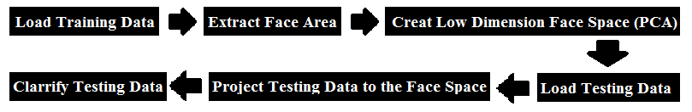

1. Data sources: A set of photos was taken which include all kinds of facial expressions such as Happy, Sad, Angry including expressionless. Here are some examples:



1. Take out the face part out of the picture and let them have all same size by face detection:

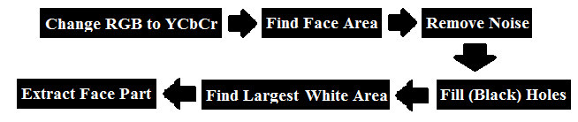

1. Original picture is RGB, first change the picture into YCbCr by using rgb2ycbcr function (like the left figure), and get only Cr part of the picture (like the right figure):

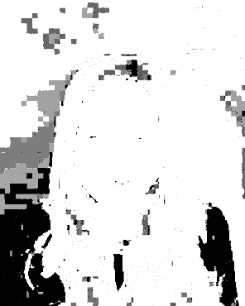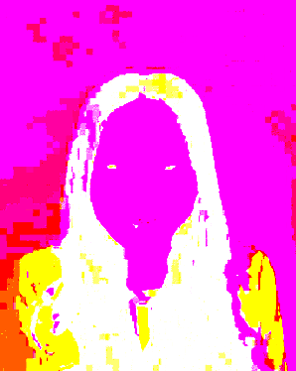

1. Use only the Cr part of the picture and then set a threshold value to extract the face area. Set a threshold: if a pixel in the Cr part is smaller than 255 and greater than 10, then make the pixel as a part of face (set the pixel as white).Otherwise the pixel is not part of the face. Then we get a figure like this:

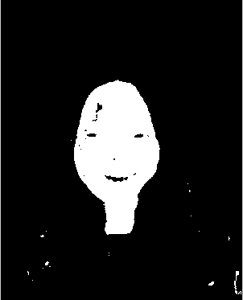

1. Lots of noise is in the previous figure, so remove noise is very important, by using average values of pixels that around a pixel to eliminate small noise:

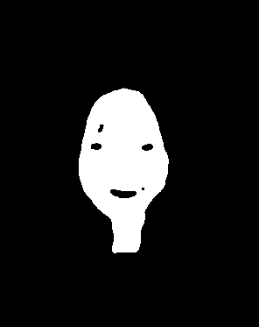

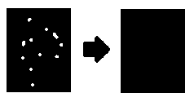

1. 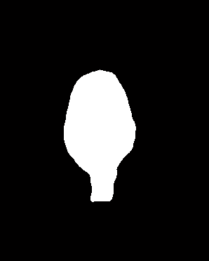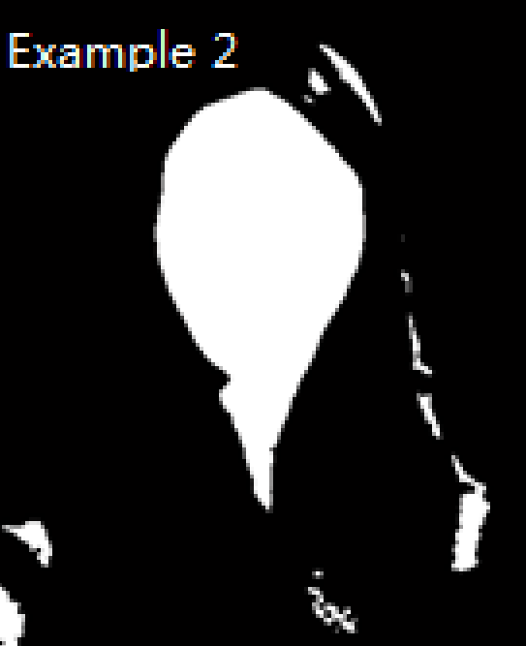There still are some small stain in and out of that area (Mainly the eyes and mouth, and also may be some other parts), so remove all those stain to make sure that the face part do not have black stain. Use imfill to remove/fill black holes : (There is no distinct white holes in the previous picture, So there is another example presented.

1. I have already got the face part but there are still some other white areas exist, but the face area is the biggest in all white areas. I use bwlabel to find white areas in the figure and use regionprops to calculate the white areas so we can find the biggest one. Then combine the original picture and the biggest white area found, which is the face area, to get the face part like following figure.

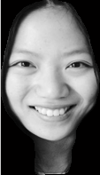

1. Since I’ve already get the face areas of training pictures, then utilize training images to create a low dimensional face space by performing Principal Component Analysis (PCA) in the training image set and taking the principal components (i.e. Eigen Vectors with greater Eigen values)1,2,3. Projected versions of all the train images are created in this process.



1. Put training images and testing images in Train folder and Test folder, put expression label in Label.txt. Then load Training data.
2. Change them into one dimension by simply put every line at the end of line above, then we can change the original figure to one dimension:

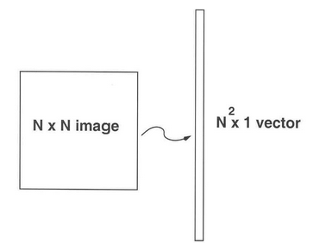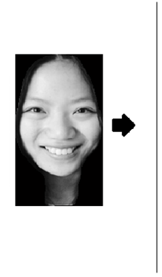

Use Γ to represent the one-dimension vector, then we get a set of transformed figures:

$$S=\left\{Γ_{1}{,Γ}_{2},Γ_{3},{……Γ}_{M}\right\}$$

Obtain the mean vector/image Ψ:

$$Ψ=\frac{1}{M}\sum_{n=1}^{M}{Γ_{n}}$$

Find the difference Ф between the input image and the mean image:

$$Ф_{i}=Γ_{i}-Ψ$$

1. Next we seek a set of M orthonormal vectors, un, which best describes the distribution of the data. The kth vector, uk, is chosen such that:

$$λ_{k}=\frac{1}{M}\sum_{n=1}^{M}{(μ_{k}^{T}Φ_{n})}$$

Is a maximum, subject to:

$$u_{l}^{T}u_{k}=δ_{lk}=\left\{\begin{aligned}1 if l=k \\ 0 otherwise\end{aligned}\right.$$

Note: $u_{k}$ and $λ_{k}$ are the eigenvectors and eigenvalues of the covariance matrix $C$

1. Then obtain the covariance matrix C in the following manner:

$$C=\frac{1}{M}\sum_{n=1}^{M}{Φ_{n}Φ_{n}^{T}}=AA^{T}$$

Where the matrix $A=\left\{Φ_{1},Φ_{2}{,Φ}_{3},……Φ_{n}\right\}$

1. The previous steps can all be done by using princomp function to do principle components analysis4,5. After PCA we get the Coeff, which is composed by all the eigenvectors of covariance matrix corresponding to face matrix. Thus, we constructed the low dimension face space by training images.
2. Project testing images on face space, so all the testing images are represented in terms of the selected principal components. Euclidian distance of a projected testing image from all the projected training images can be used to classify training images. Intensity of an expression can be represented by its distance to neutral expression1,3.



1. Like the step 2.a, first thing need to do is load test images (Γ) and transform the images to one-dimension images like step 2.b.
2. Normalize testing images:



Project testing images (Γ) on the eigenspace. First compare input testing image with mean image and multiply their difference with each eigenvector of the L matrix. Each value would represent a weight and would be saved on a vector Ω:

$$ω_{k}=u_{k}^{T}(Γ-Ψ)$$

$$For k=1,2,….M Ω^{T}=[ω_{1},ω_{2},……ω_{M}]$$

1. All training data and testing data are prepared, it is time to calculate the distance of testing data to training data in the face space. Then we calculate Euclidean distance:



1. In order to define the expression of the images. We need to find the best match of the testing images in training images. So after we calculate the Euclidean distance. Then I use KNN classifier (find the nearest neighbor) to find the best match in the training images of testing images, then I classify all testing images to different facial expressions.

Results:

Then I successfully defined the facial expression of the given images and the results are put in the results.txt, the results is following, the first column is the name of the testing image file, second column is its distance from neutral image, third column is its expression and the fourth column is file name of its best match in training images:

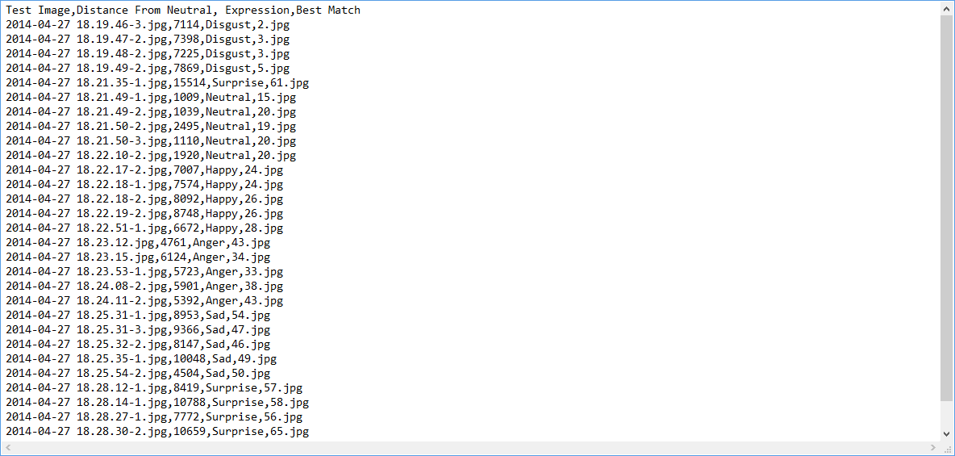

In classify the testing images, I put around different 20 images in Test folder each time, and then I get the accuracy:

$$Accuracy=\left(\frac{Right Classification}{Amount of Testing Images}\right)×100\%$$

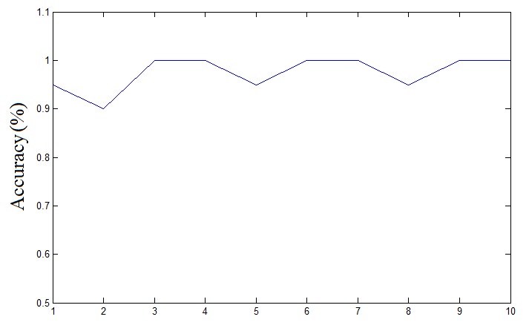

This figure points out the accuracy of the program, each time there are only at most one or two wrong-classify images. So this program works very well to define the facial expression of testing data.

Conclusion:

In order to full fill this project, multiply pattern recognition technologies are used. First thing is face detection to extract the facial part of the images. Then use do PCA to the training images and created low dimension face space. Finally, calculate Euclidean distance and classify testing images.

References:

1. M. Turk and A. Pentland (1991). ["Face recognition using eigenfaces"](http://www.cs.ucsb.edu/~mturk/Papers/mturk-CVPR91.pdf). Proc. IEEE Conference on Computer Vision and Pattern Recognition. pp. 586–591.
2. L. Sirovich and M. Kirby (1987). "Low-dimensional procedure for the characterization of human faces". Journal of the Optical Society of America A4 (3): 519–524.
3. M. Turk and A. Pentland (1991). ["Eigenfaces for recognition"](http://www.cs.ucsb.edu/~mturk/Papers/jcn.pdf). Journal of Cognitive Neuroscience 3 (1): 71–86.
4. [Abdi. H., & Williams, L.J.](http://en.wikipedia.org/w/index.php?title=AbdiWilliams&action=edit&redlink=1)(2010). "Principal component analysis.". Wiley Interdisciplinary Reviews: Computational Statistics, 2: 433–459
5. Principal Component analysis in Wikipedia <http://en.wikipedia.org/wiki/Principal_component_analysis>

Xinyun Jiang

4/27/14

Part of images that use for training data and also testing data (I prepared 15 images for each expression and half of them is training data and another half is testing data):

1. Anger:

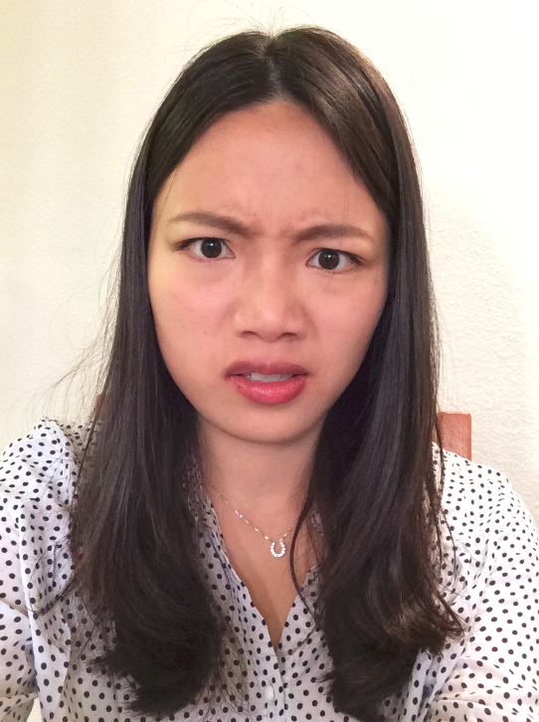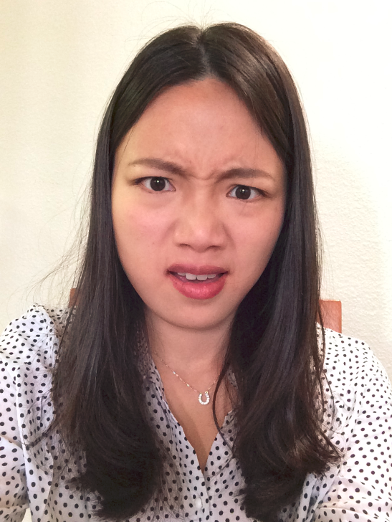 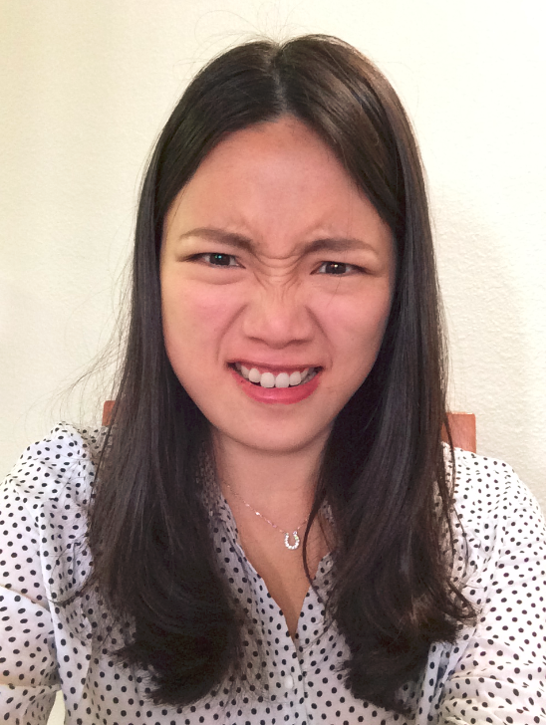 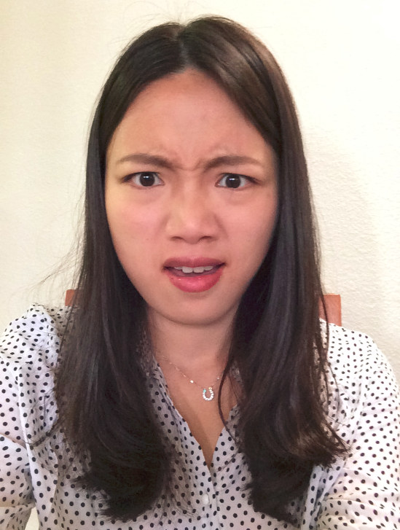

1. Disgust:

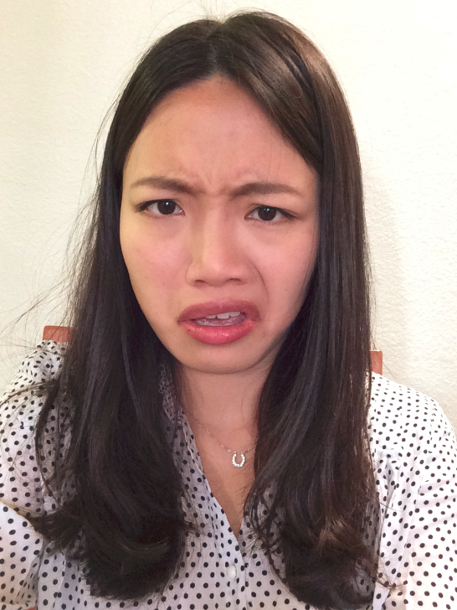 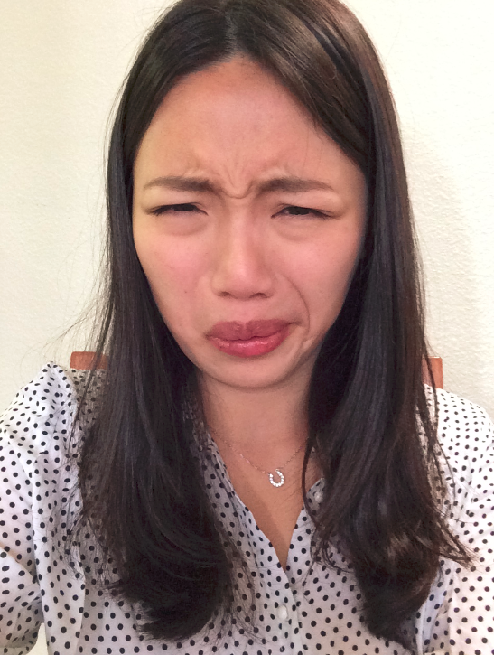 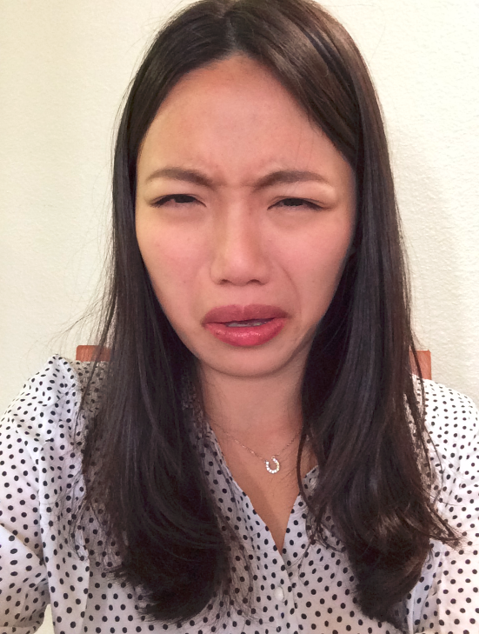 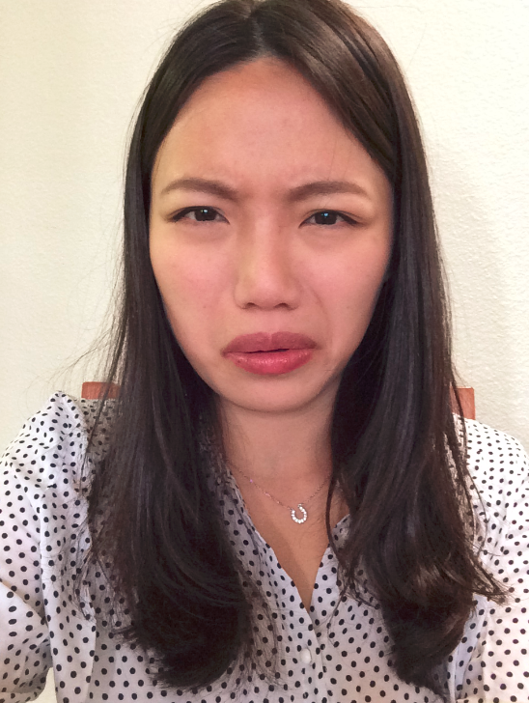

1. Happy:

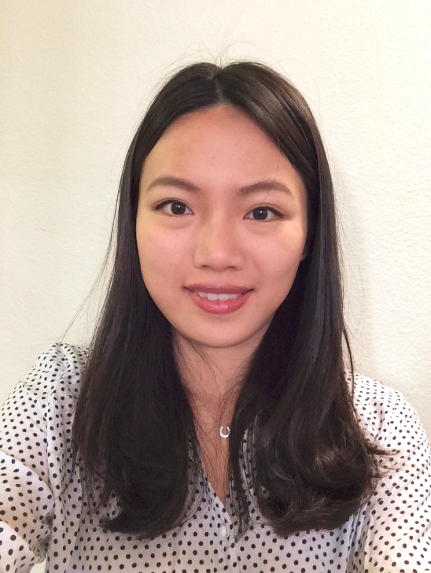 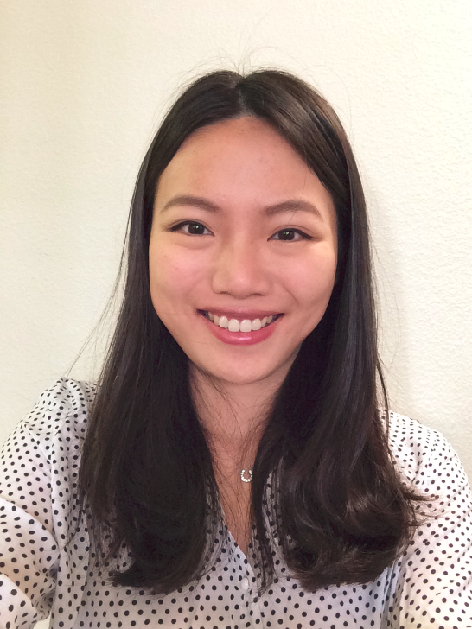  

1. Sad:

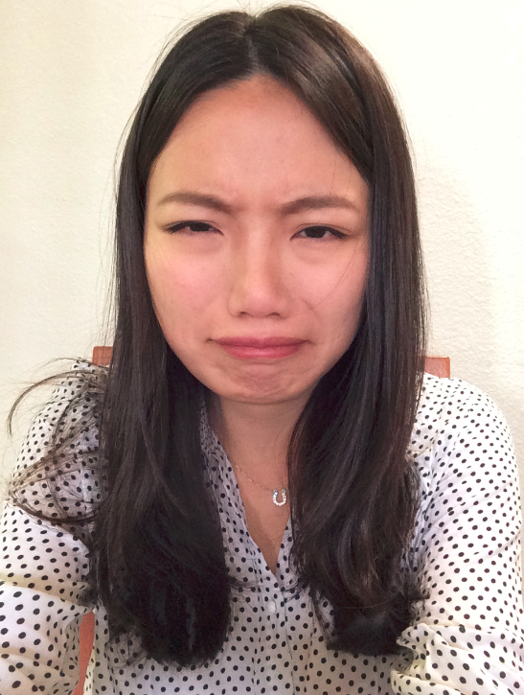 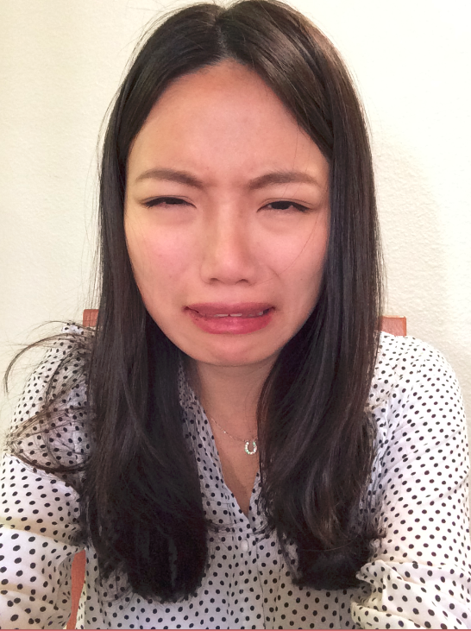  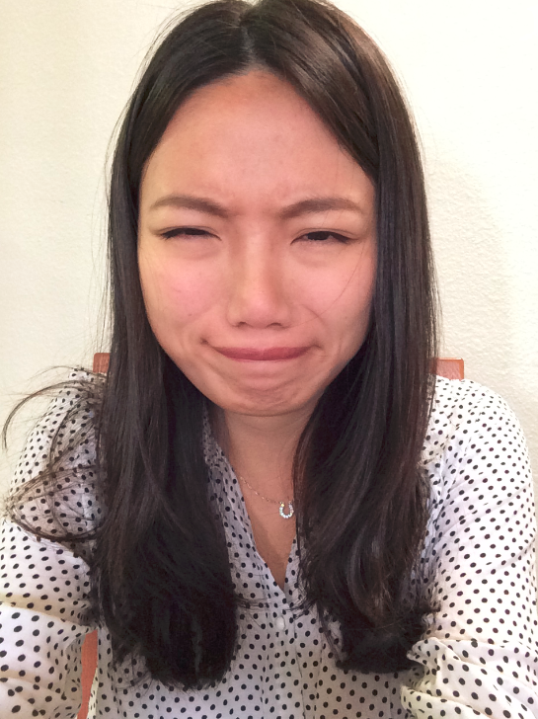

1. Surprise:

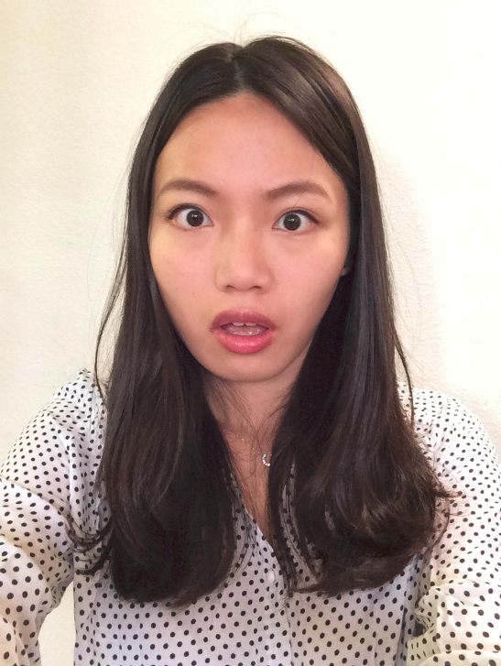 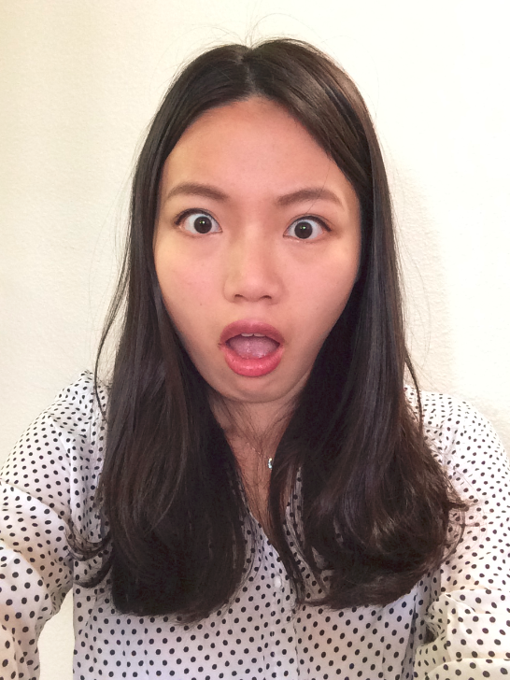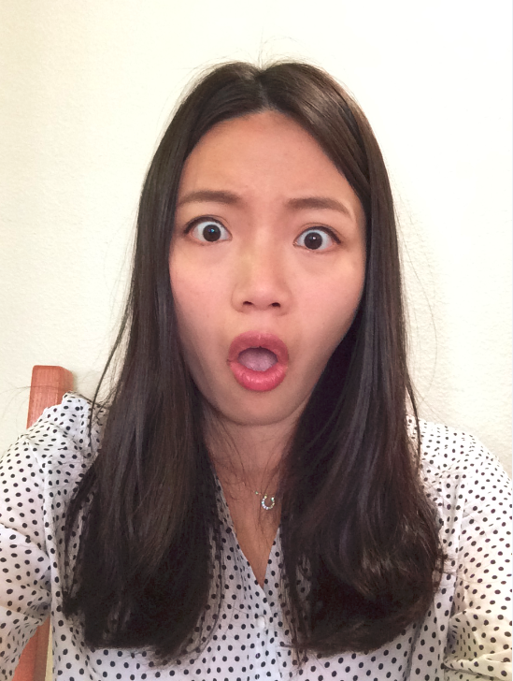 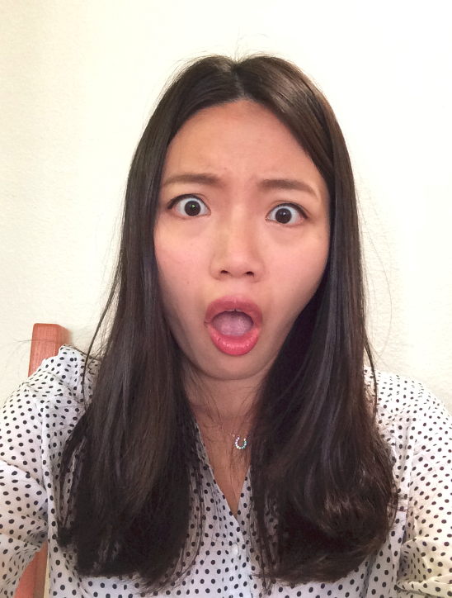

1. Neutral:

